Medication Reminder App – Survey Result Analysis & Requirement Engineering

To further understand what users expect from a medication reminder app, we conducted a survey through google forms. This document analyses the results of the survey and the features of similar existing products in the market in order to identify user needs and expectations, project objectives, determine scope, identify stakeholders and user groups for the project.

Survey Data Analysis

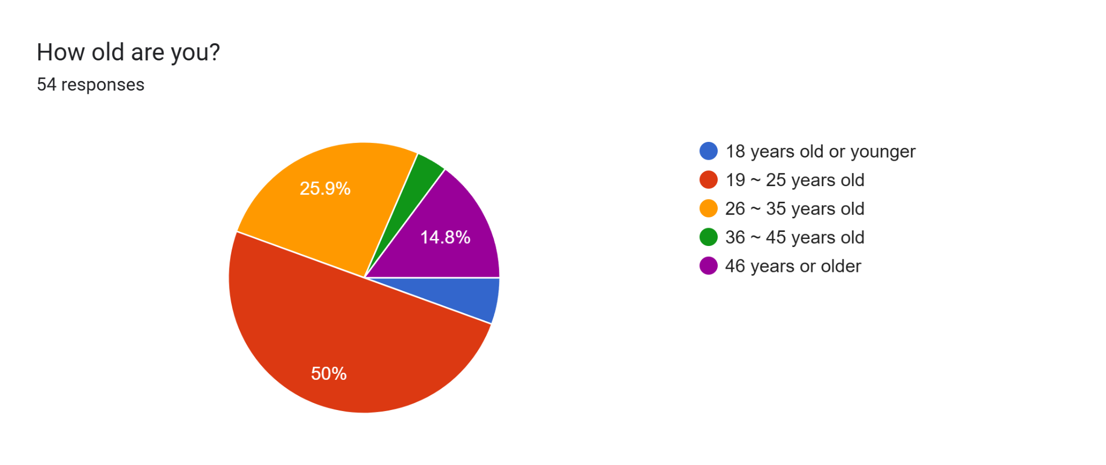
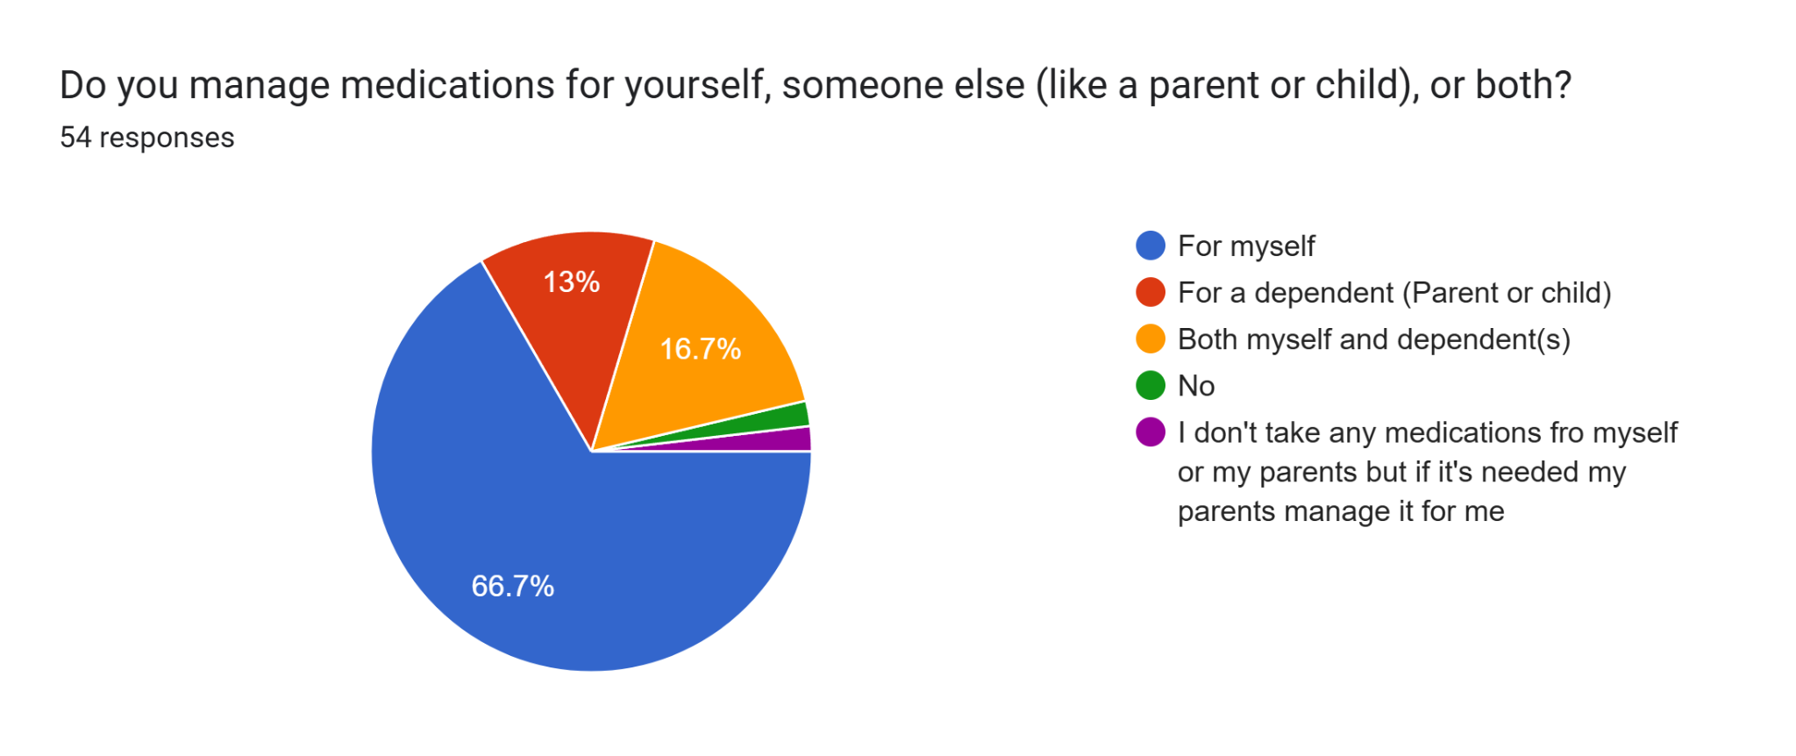
From the above data, we can assume that the majority of the respondents are young adults who manage medication for themselves.

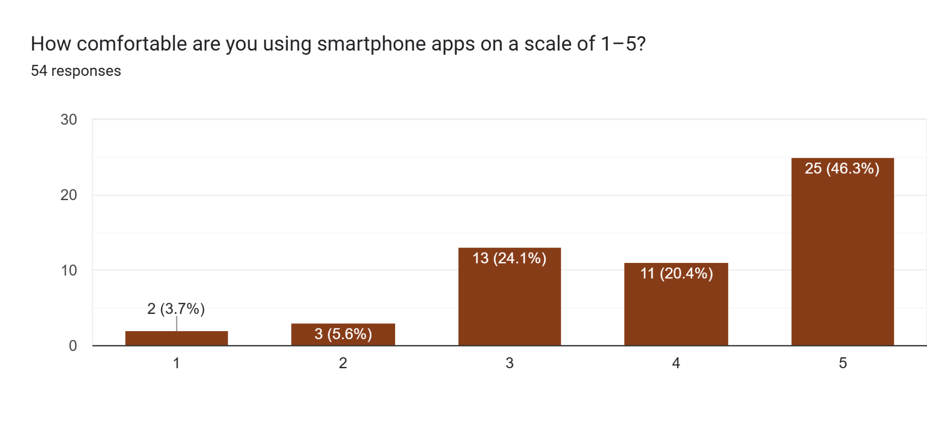
The above data shows that most respondents are comfortable and familiar with using smartphone apps.

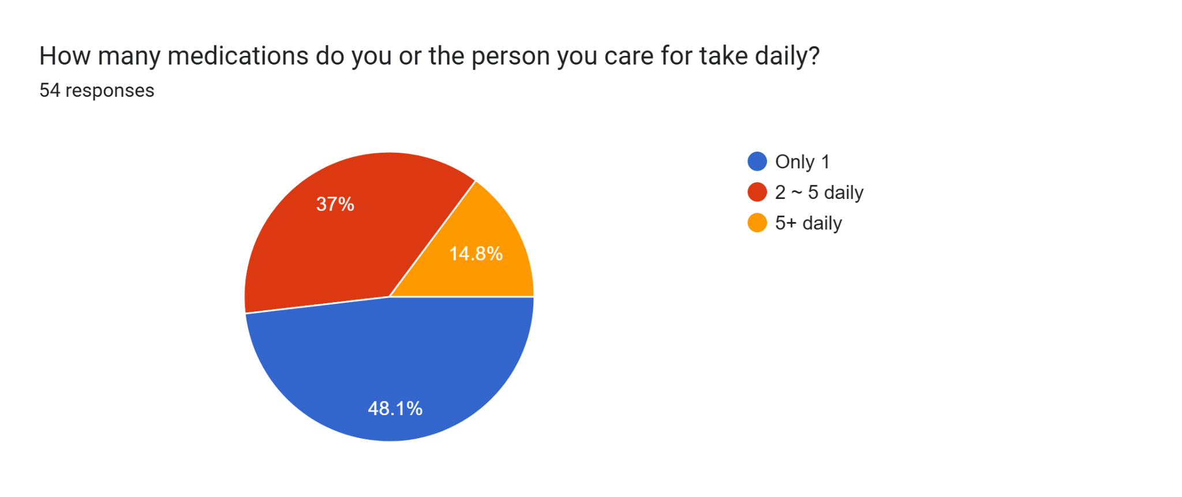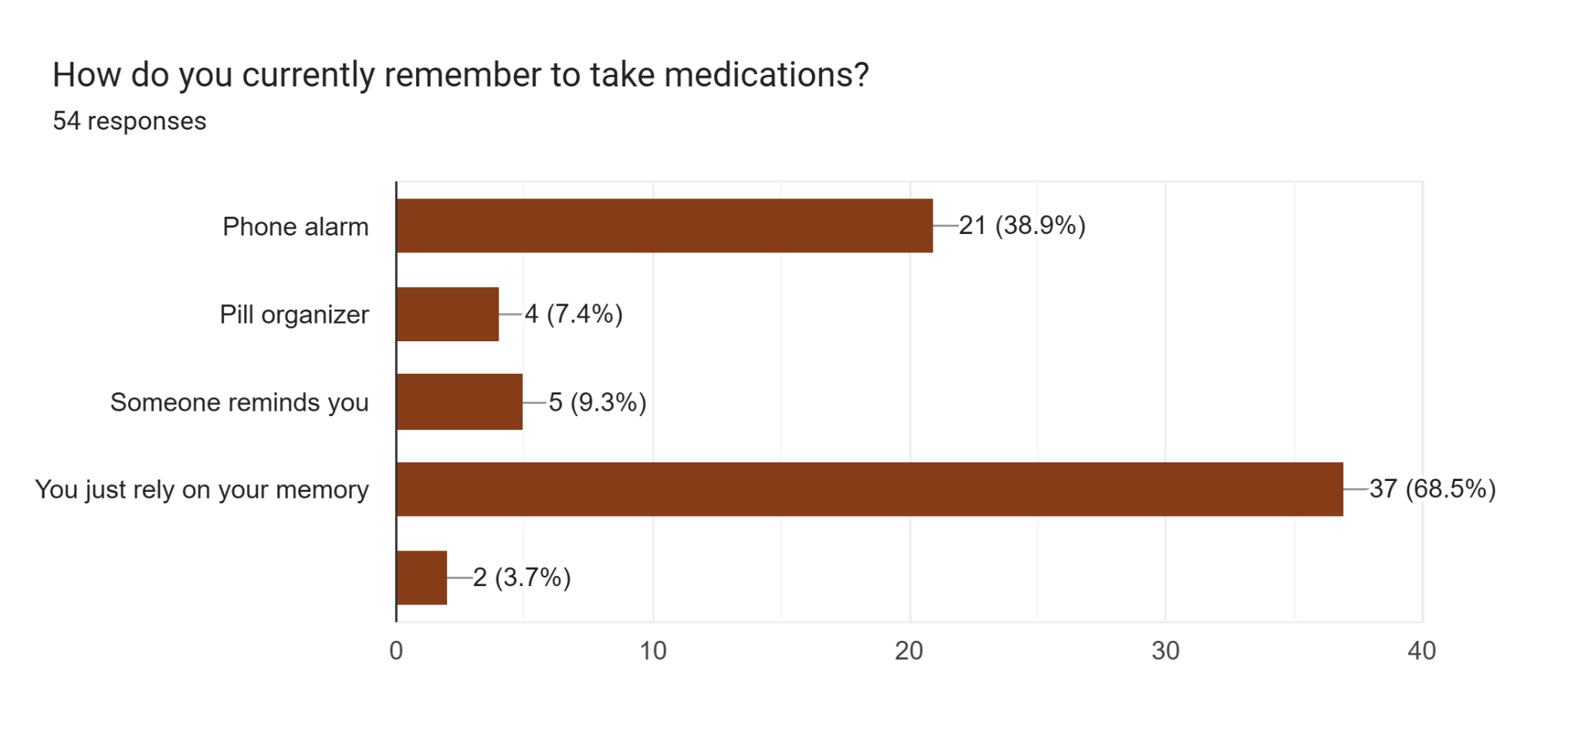
The data above shows that most respondents take at least one medication daily. Most of them rely on their memory to remember to take them on time.
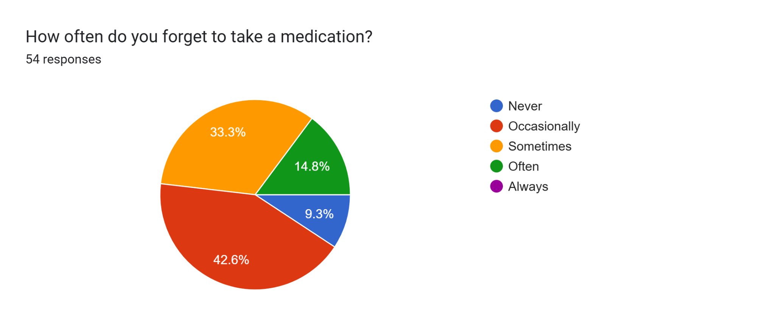
When asked how often they forget to take medication, we can see that only 9.3% percent of respondents answered ‘never’. Which leads us to believe that relying solely on memory isn’t a reliable way to remember to take medication.
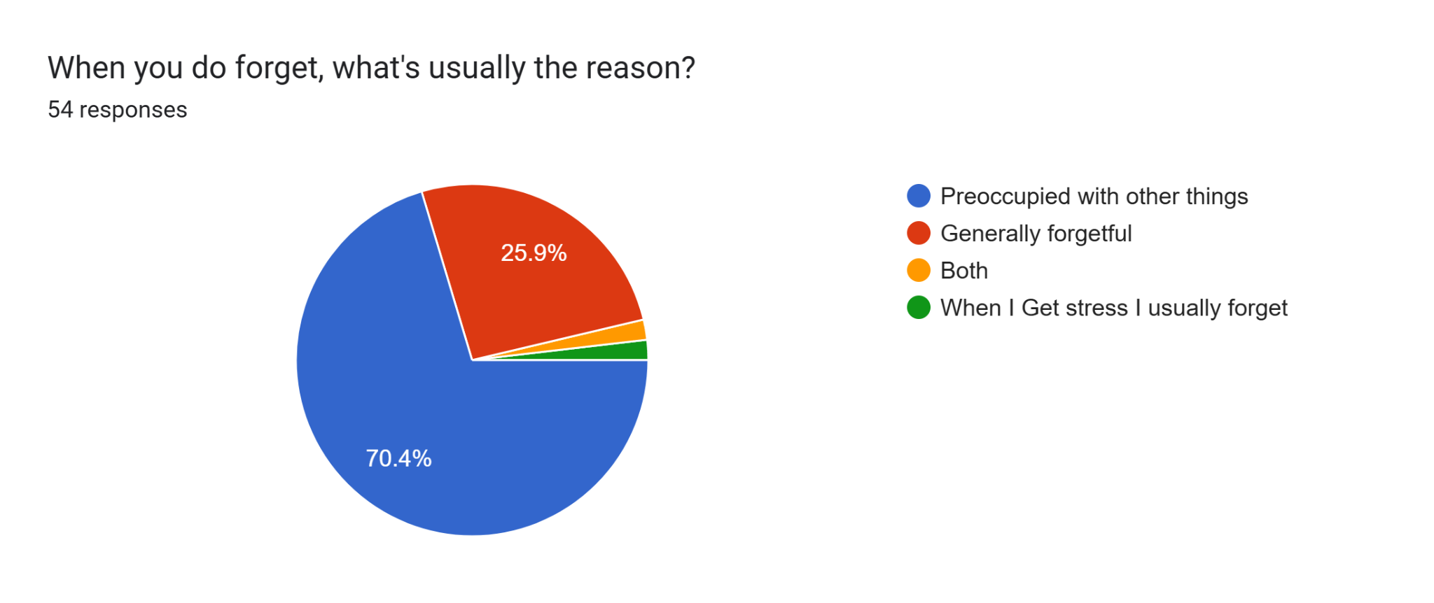
Most respondents forget to take medication due to being busy with other things in their daily life. Which is understandable as medication is just one task among many others in the average person’s routine so it’s easy to forget.
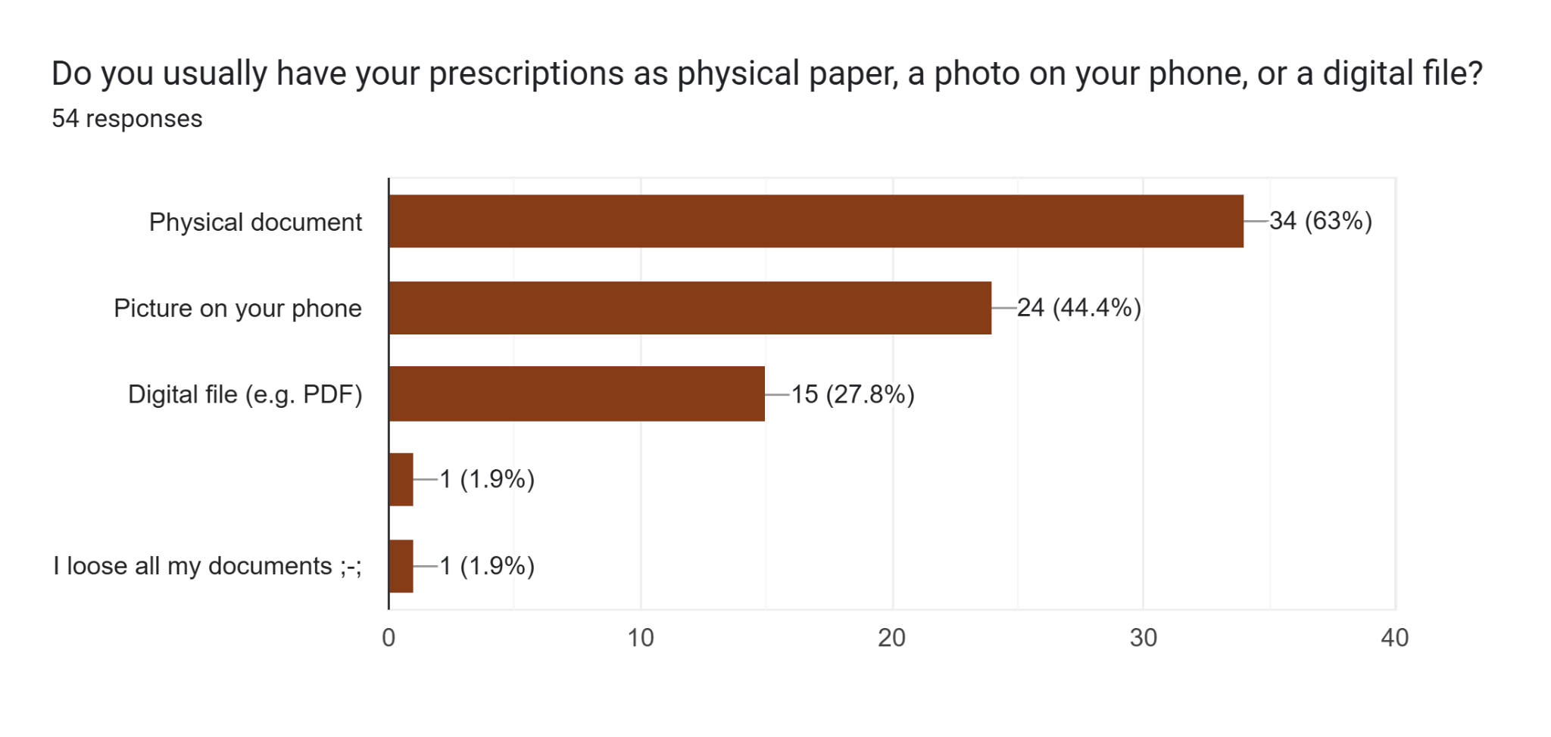
As for medical documentation, most respondents have physical copies of their medical documents, a close second being pictures on their phones at 44.4%.
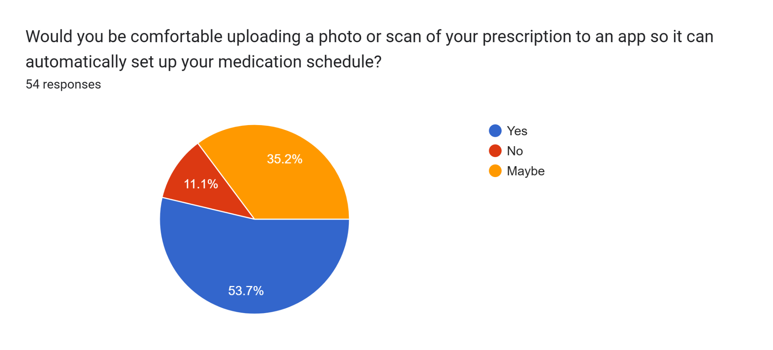
Most respondents were comfortable with the idea of uploading a photo or scan to an app. This could work well as a feature alongside proper data privacy measures to possibly assure the more hesitant respondents who answered ‘maybe’ and ‘no’.
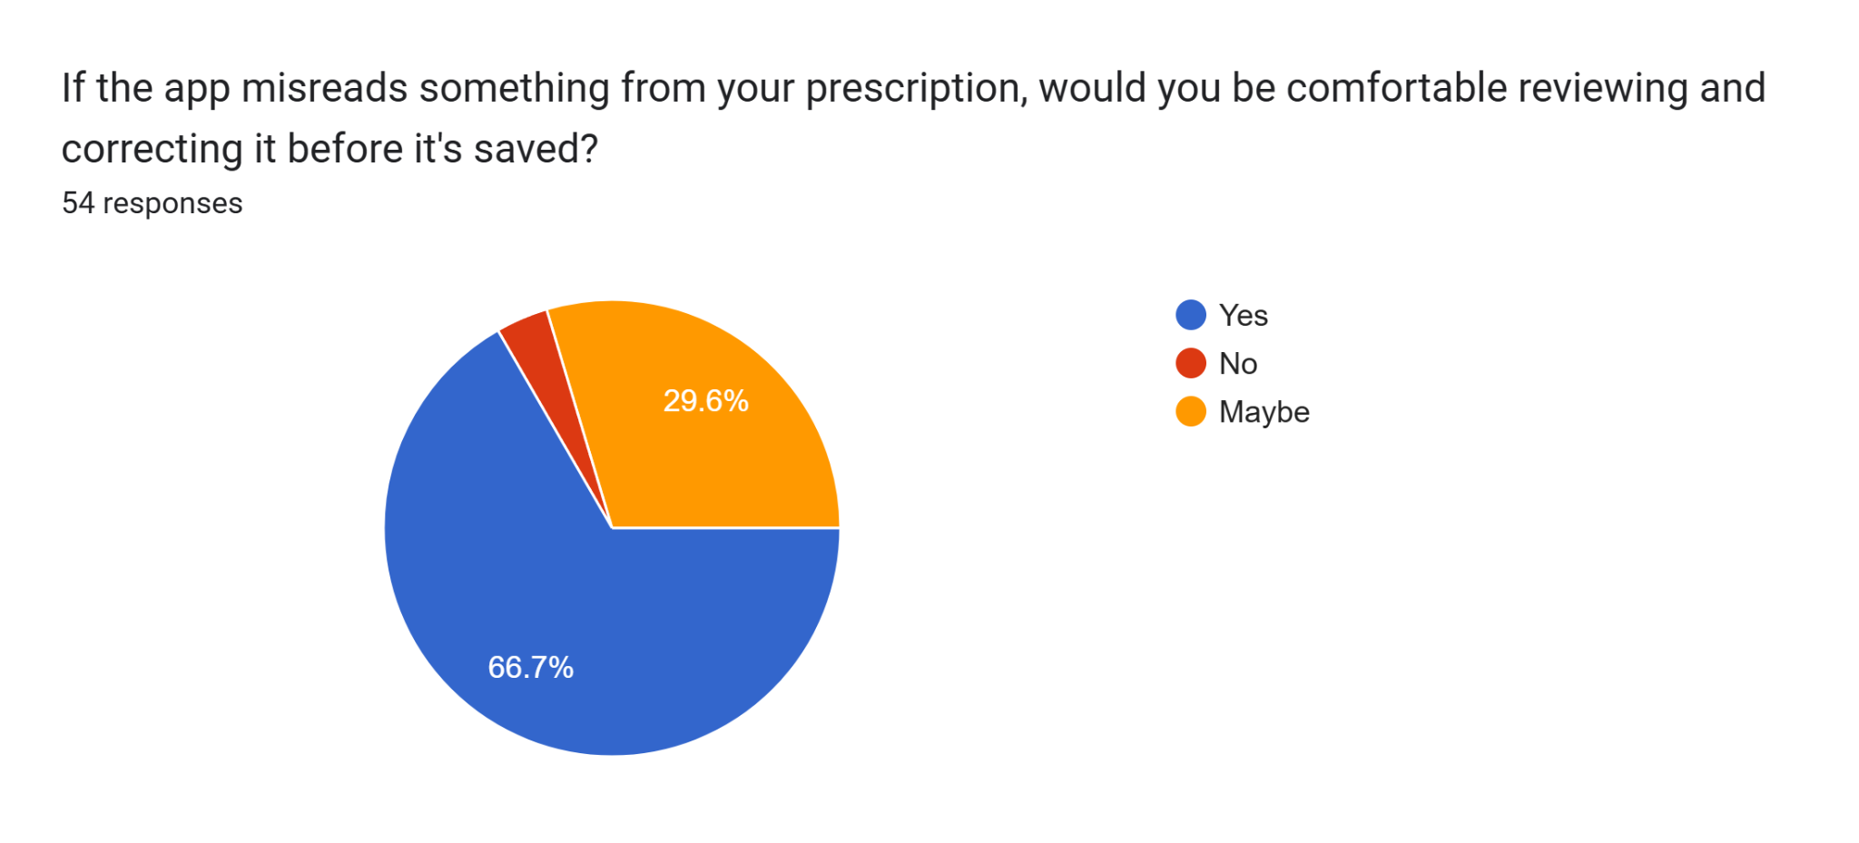
The above data shows that more respondents preferred to review the extracted data prior to saving in order to verify the accuracy of the information. There’s a notable decrease of ‘no’ responses compared to the previous graph, which leads us to believe that the initial skepticism may be attributed to uncertainty regarding privacy and data accuracy. If these specific areas are enforced, users may be more comfortable with using a medication reminder app.
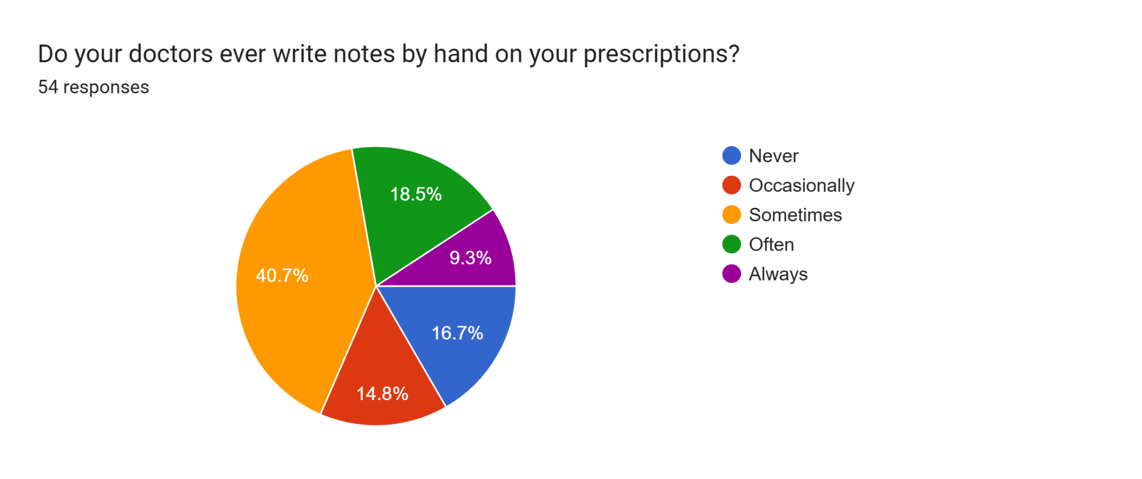
Most respondents confirmed that their doctors do write notes on their prescriptions, which may make it difficult for the app to scan due to handwriting discrepancies. This further validates why most respondents would prefer to confirm the extracted data as mentioned in the previous graph.
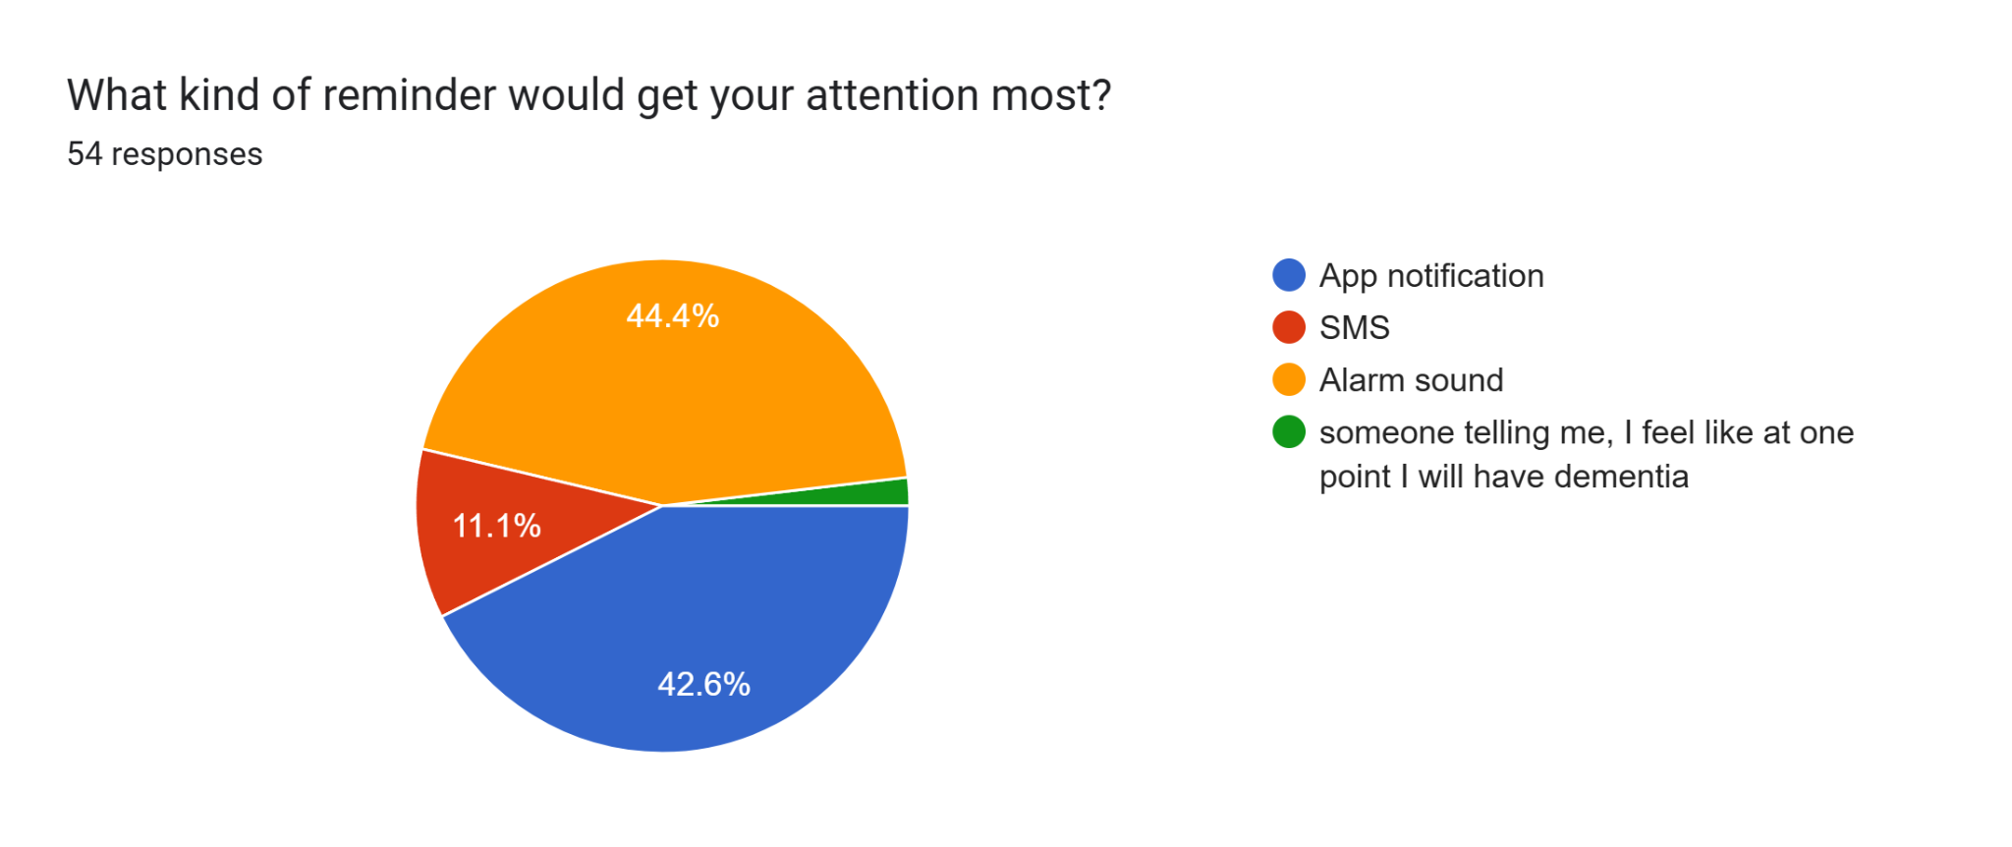
The above data shows that most respondents would pay attention to app notifications and alarm sounds. This further supports the idea that a medication reminder app can be beneficial for patients who take regular medications or even short medication courses. Patients can choose to enable what type of notifications and/or alarms they want.
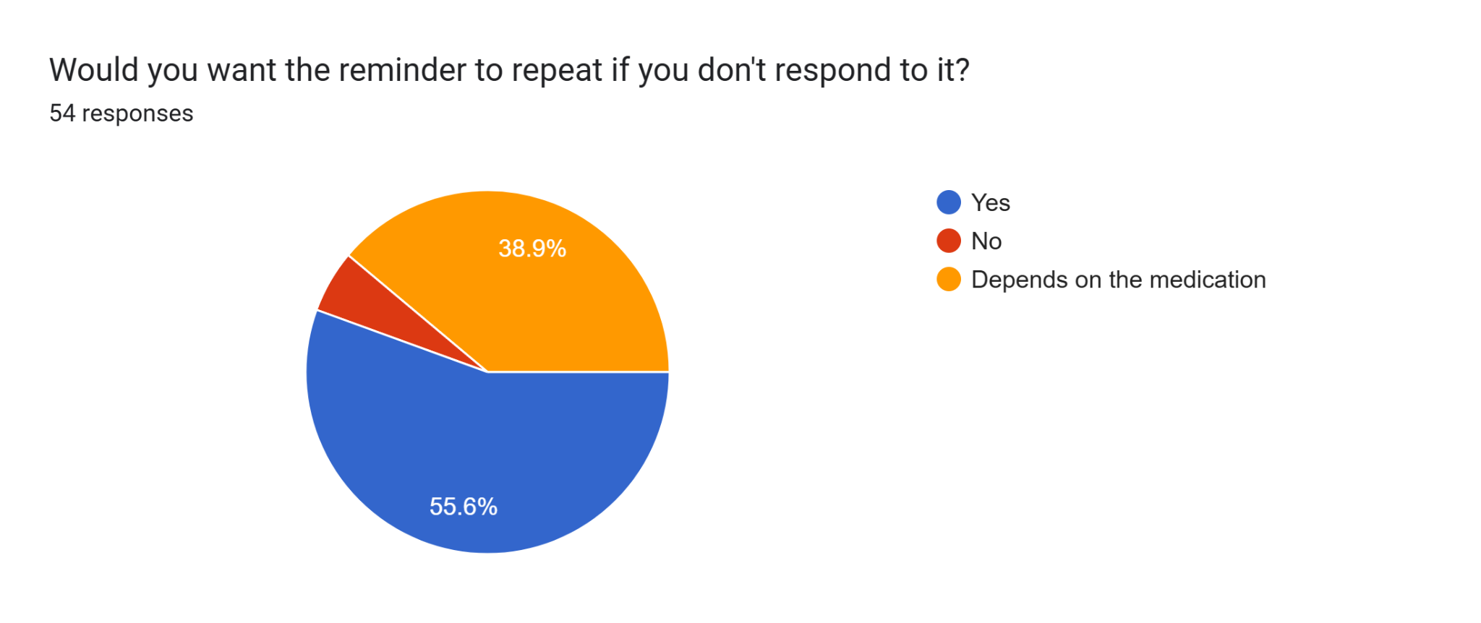
The majority of the respondents answered ‘yes’ when asked if they wanted the reminder to repeat if they didn't respond to the initial alarm/notification. 38.9% said that it depends of the medication. This shows that users would prefer having the choice of customizing notifications/alarms for individual medications depending on how critical it is and/or whether it is a medication that is time bound.
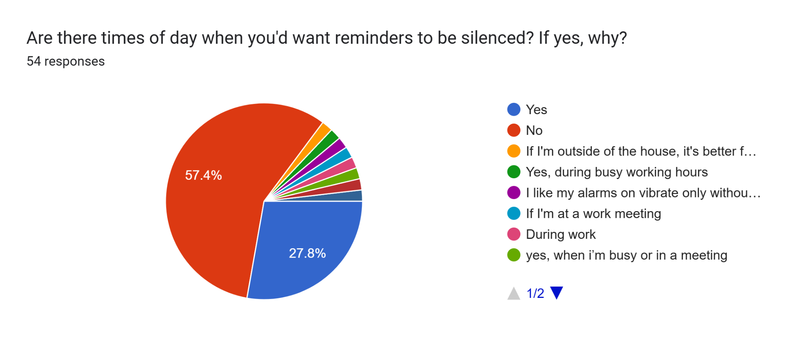
Most of the respondents confirmed that there are times of the day where they would like reminders to be silenced. The overall reason being that they did not want to have a loud noise interrupting them in public settings. This further supports the need for notification customizability in a medication reminder app.
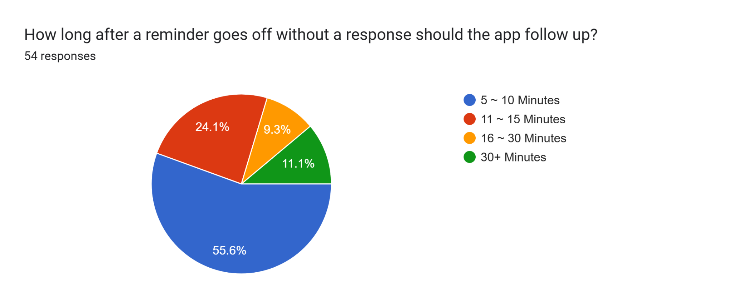
Answers for the above question varied quite a bit. Including an additional reminder frequency customization would be ideal as well since different medications have different priorities.
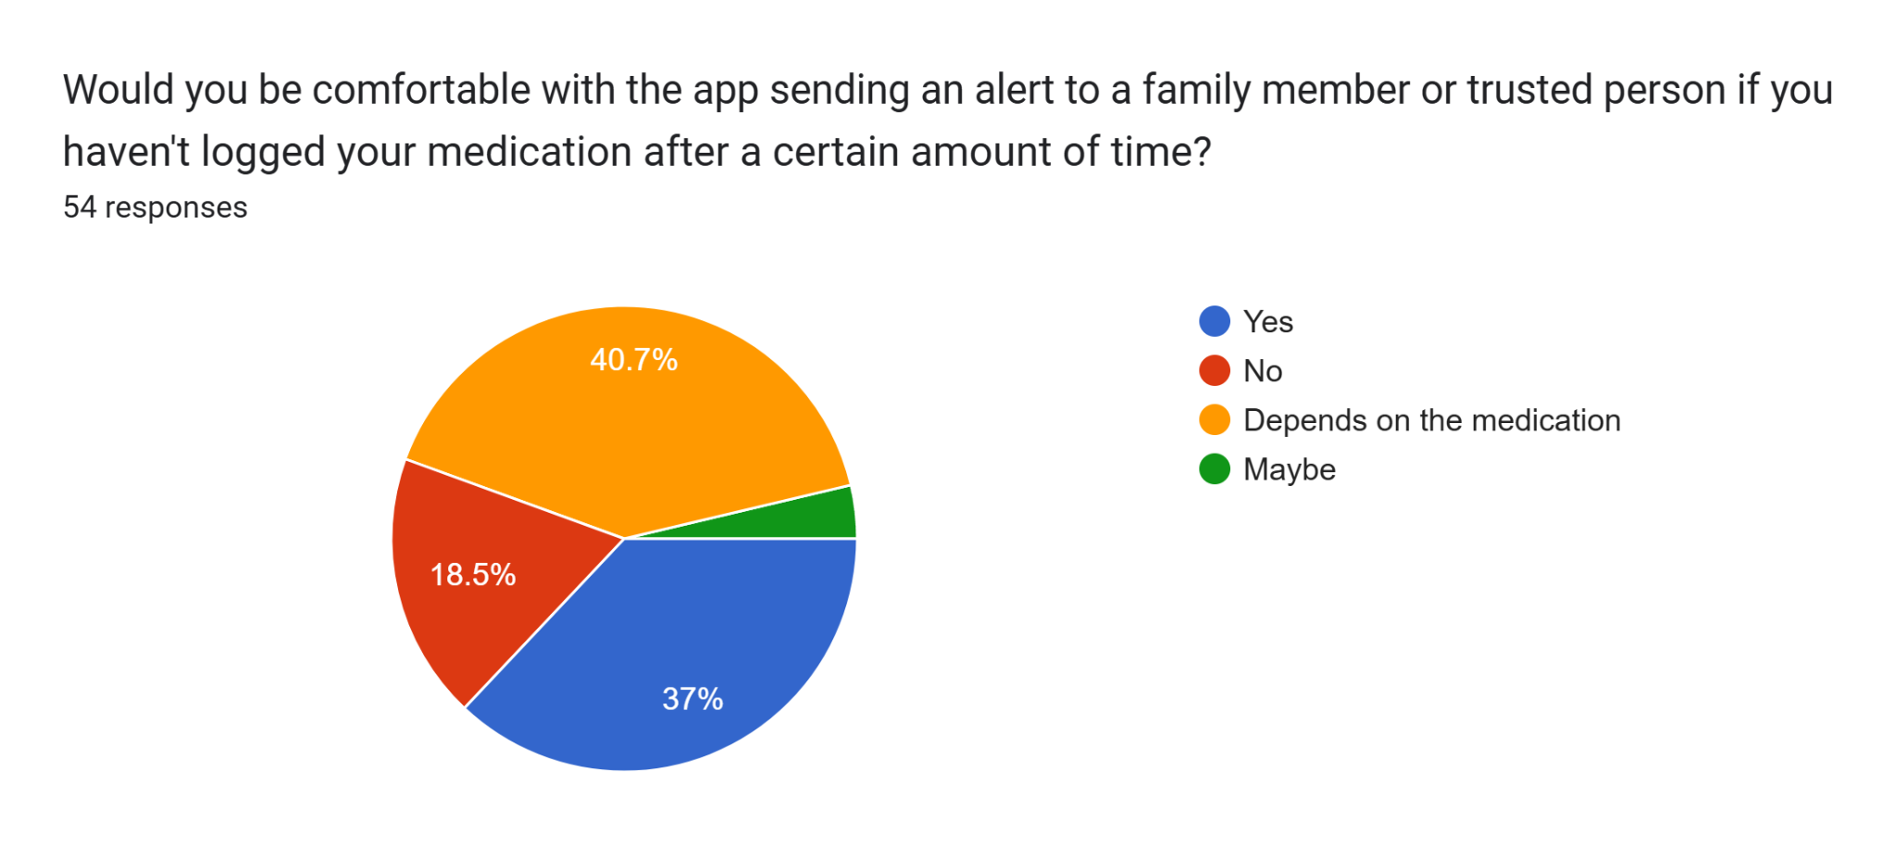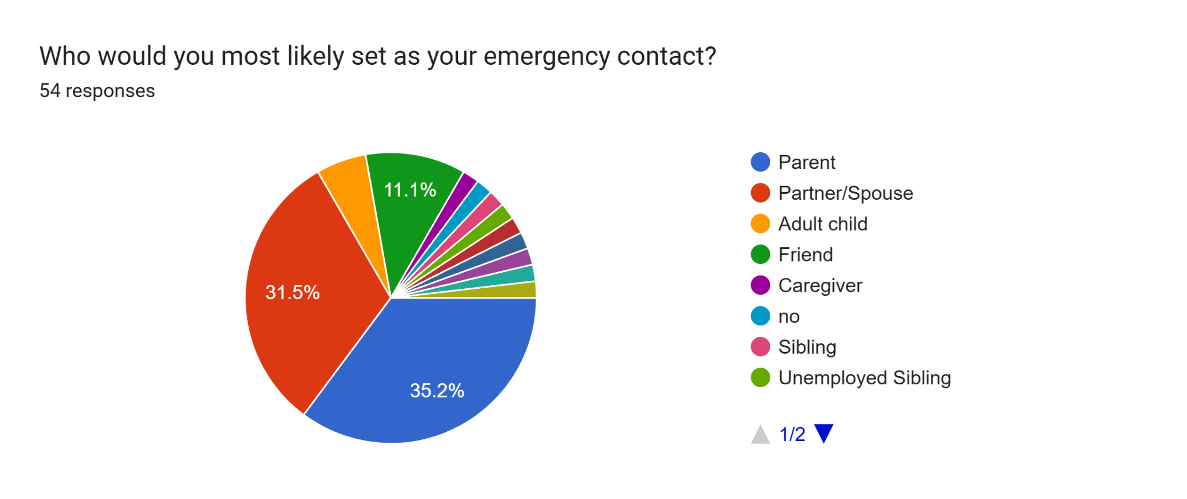
Most of the respondents said that they would be comfortable with the app sending an alert to a set emergency contact if they haven’t logged their medication for a certain amount of time but it depends on the medication. This shows that users would prefer to have an option to set priorities for individual medication, differentiating critical medication that patients can’t afford to miss from medication that aren’t as critical to their health. Users should also have the freedom to set whoever they want as their emergency contact.
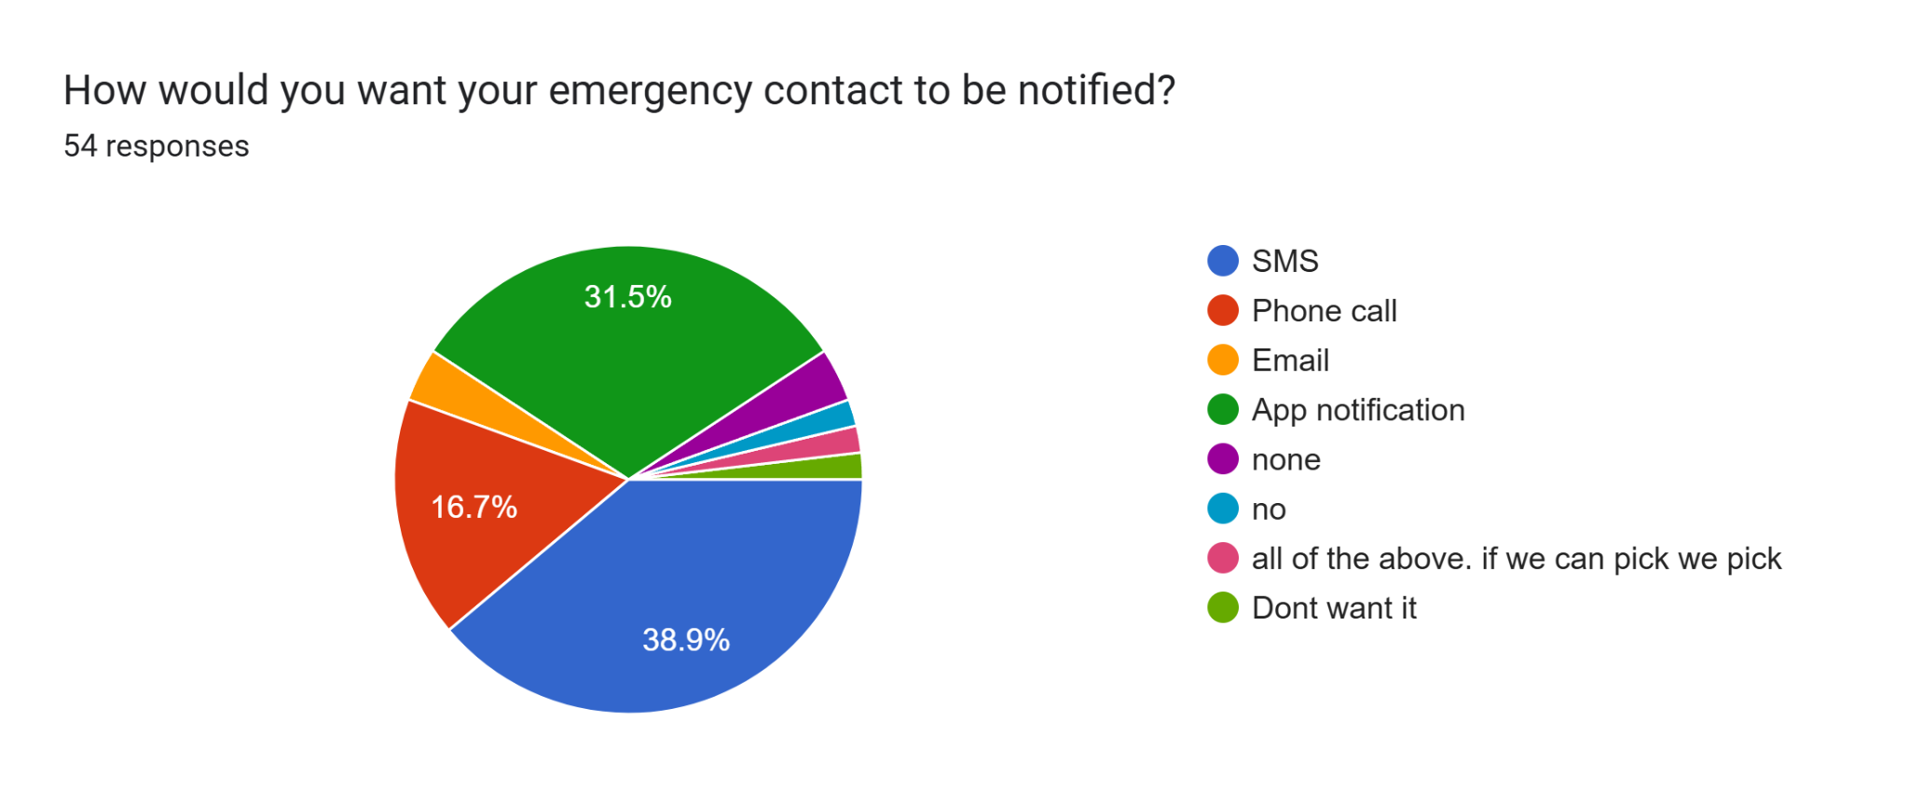
Responses were mixed for this question as well, some users preferring app notifications for their emergency contacts over SMS or even phone calls. Since these emergency contacts are alerted for medications where the user has emergency alerts enabled, we believe that a feature where the user can choose how the emergency contact is alerted when setting up the contact is ideal.
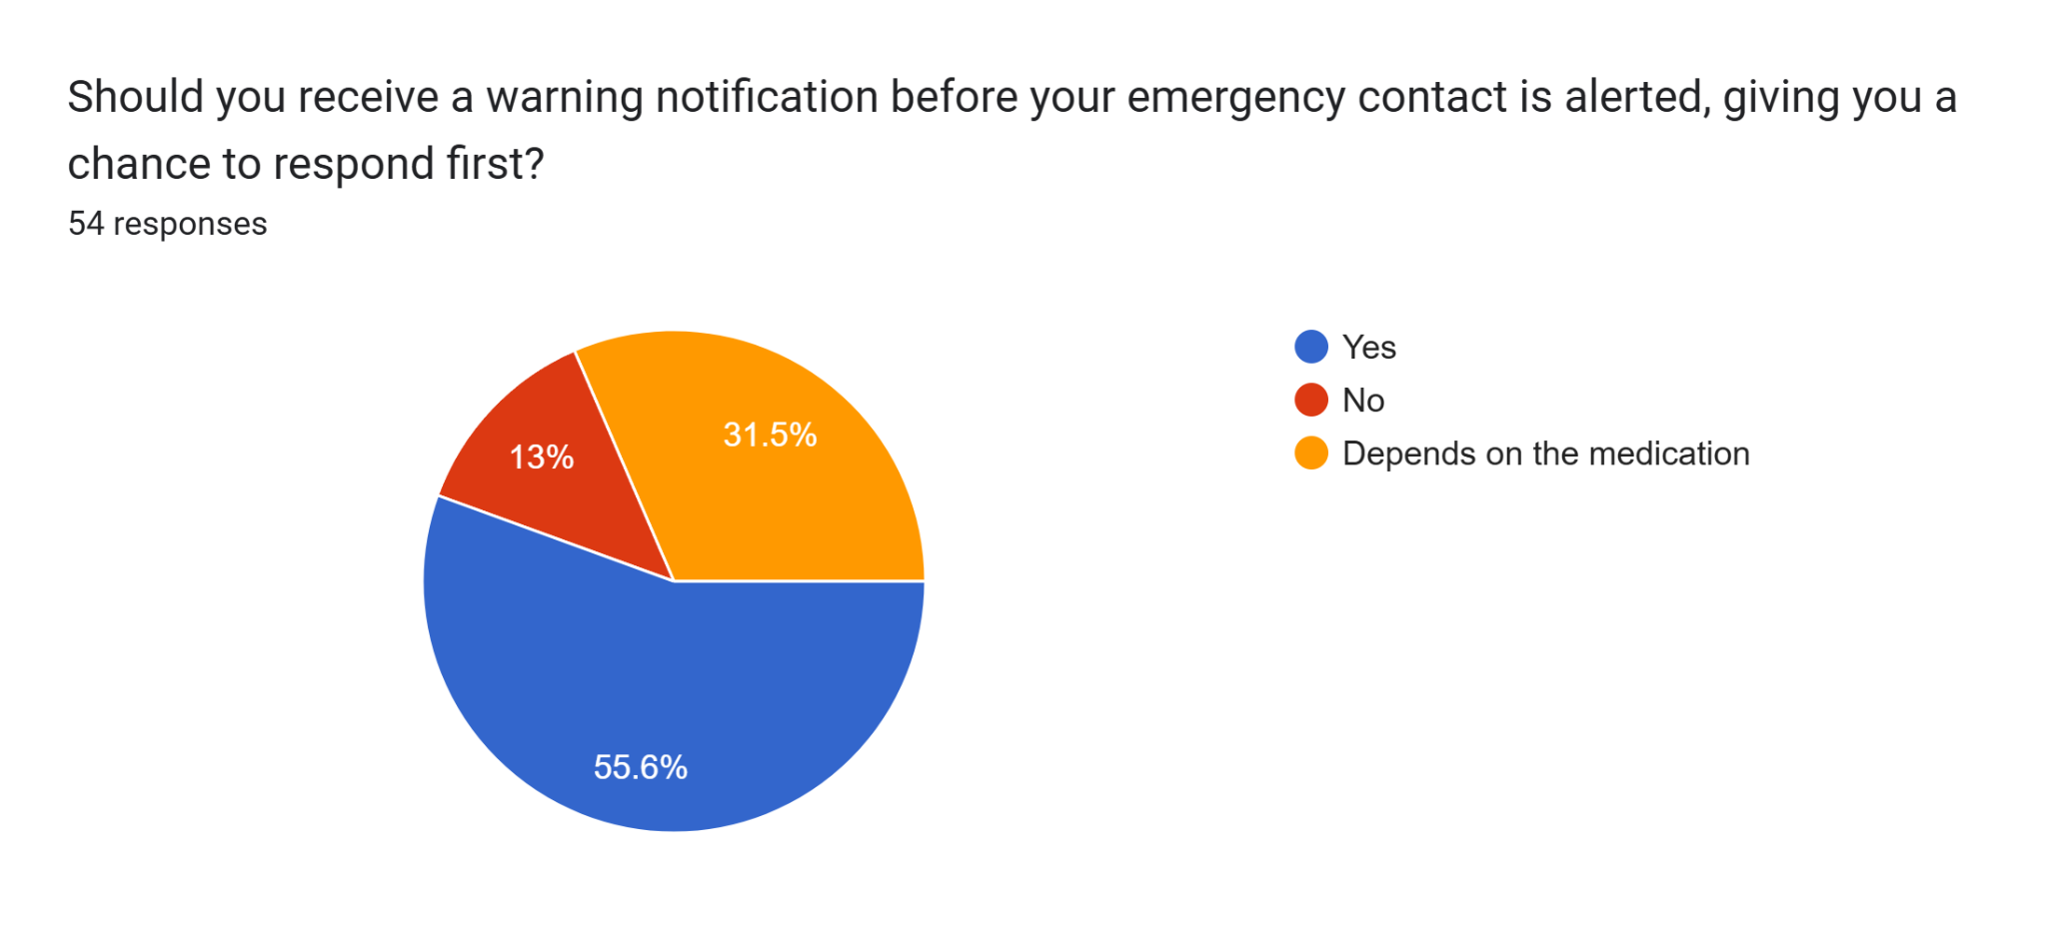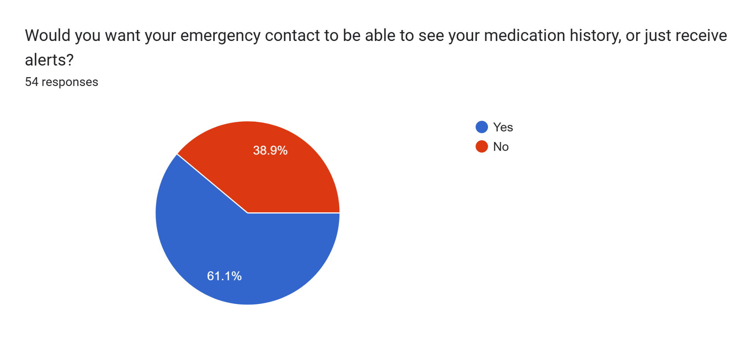
The above data further supports the need for customizability for emergency contact alerts and access as mentioned in the previous graph.
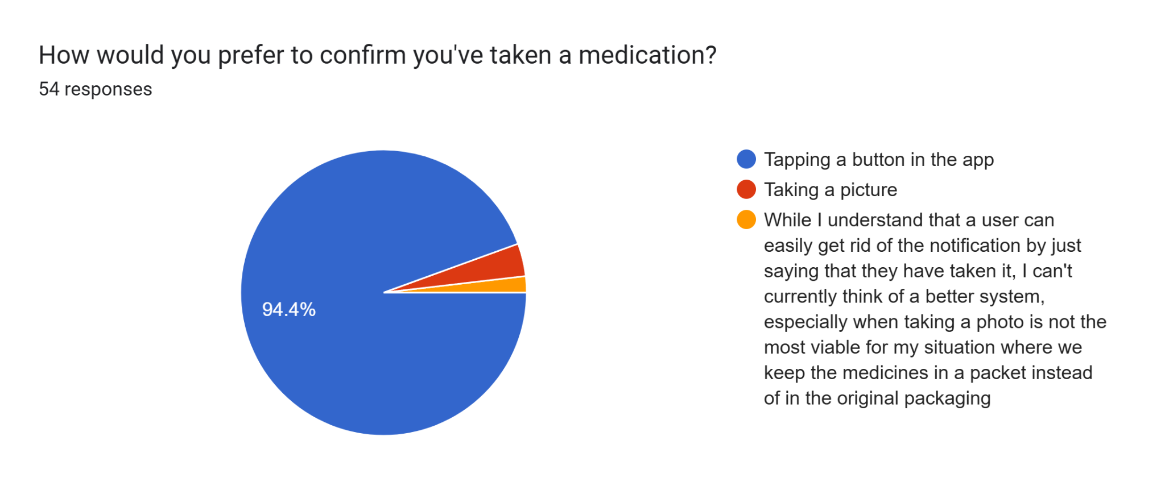The above data shows that most respondents prefer to click a button on the app to confirm that they have taken the medication that they got the reminder for. One respondent highlights that the accuracy of the data is heavily dependent on the honesty of the user who is self-reporting their medication intake. This is a constraint that seems to be unavoidable with a medication reminder app.
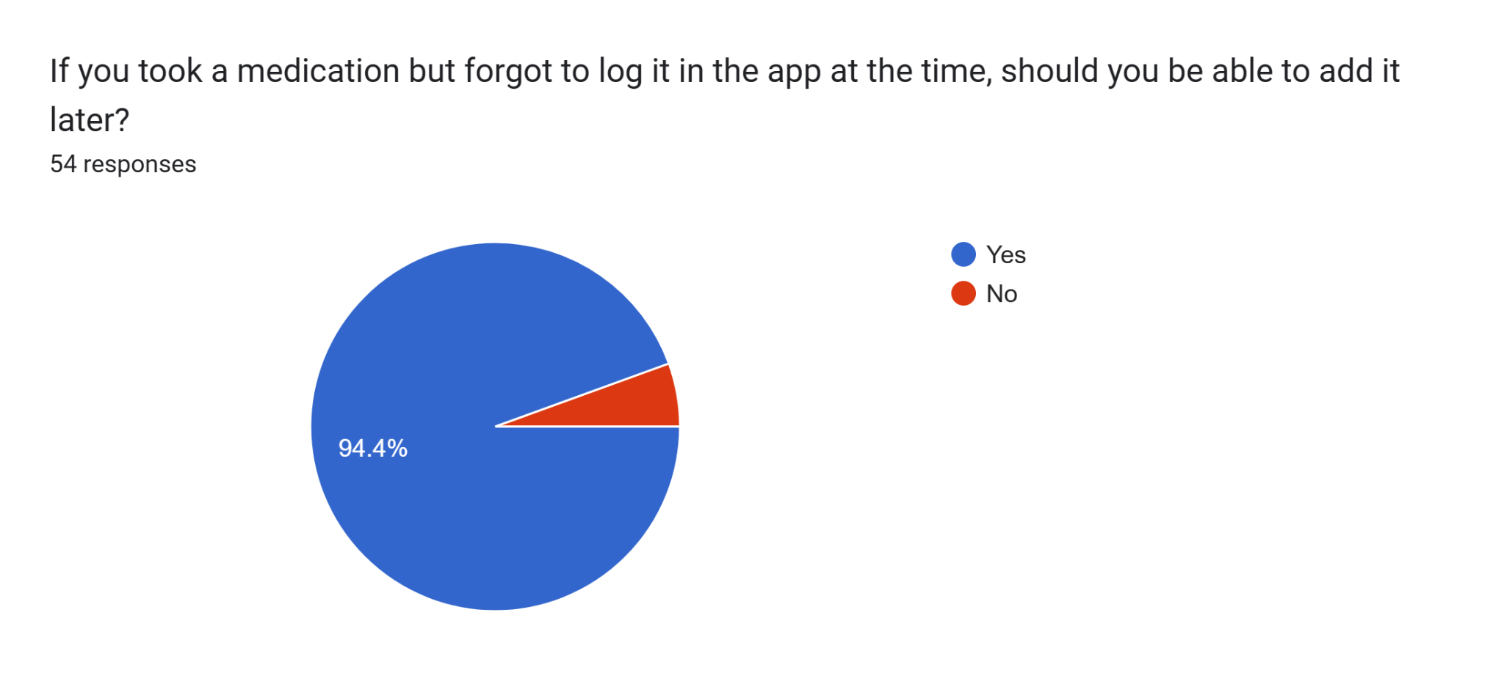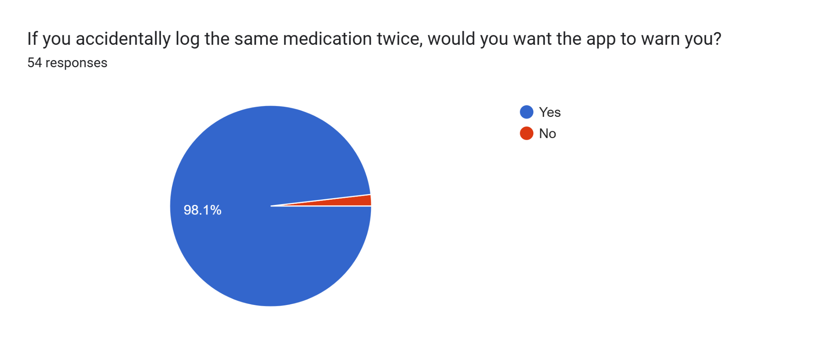The above data further highlights the importance of accuracy when self-reporting medication intake. Since the app can neither validate or confirm whether the user has taken the required medication or not, the accuracy of the medication records are entirely dependent on the user. Therefore, the user must be able to edit records in order to ensure accuracy of data.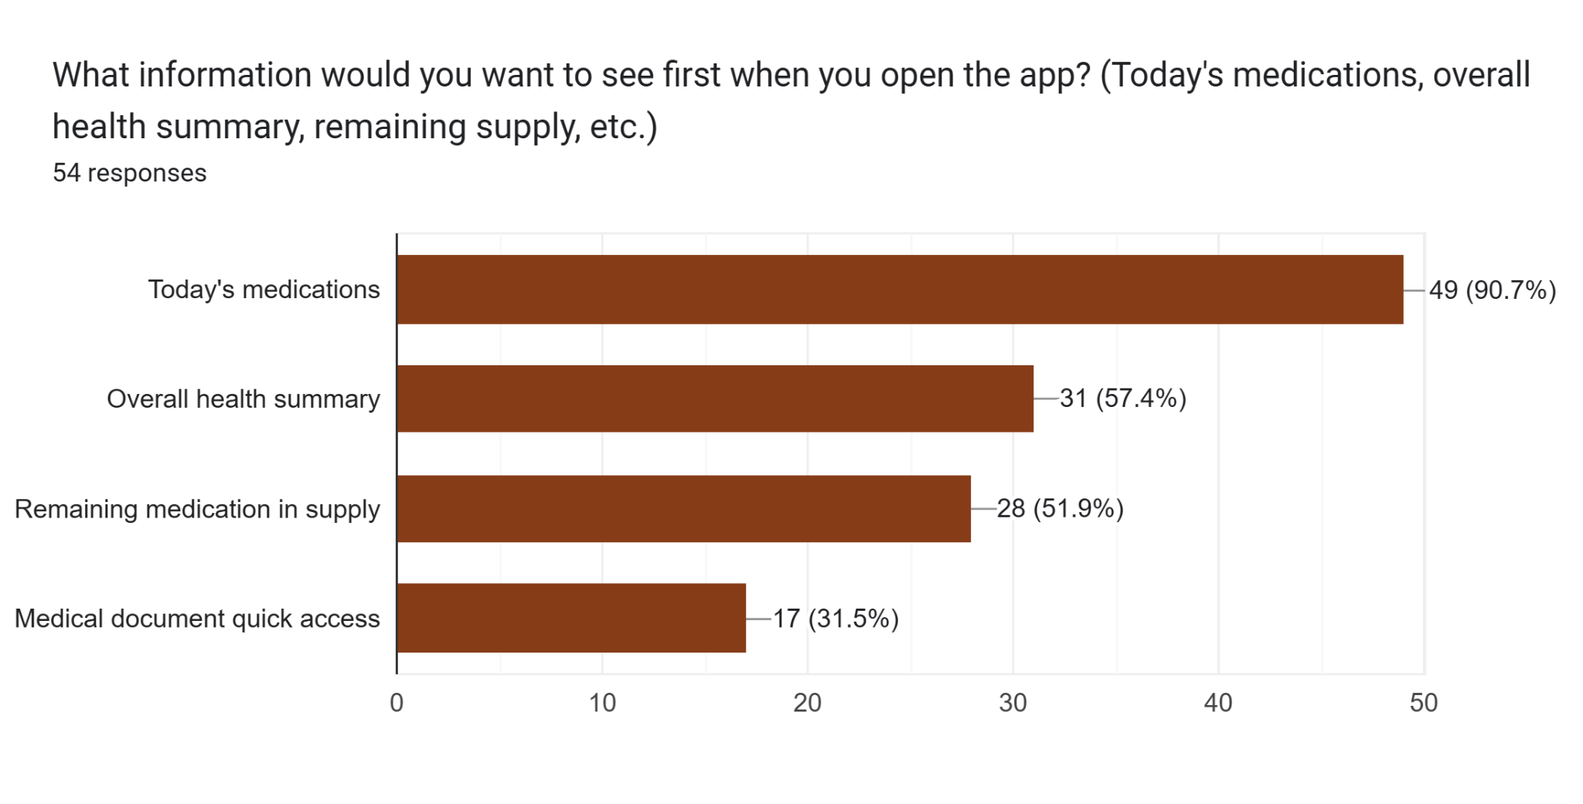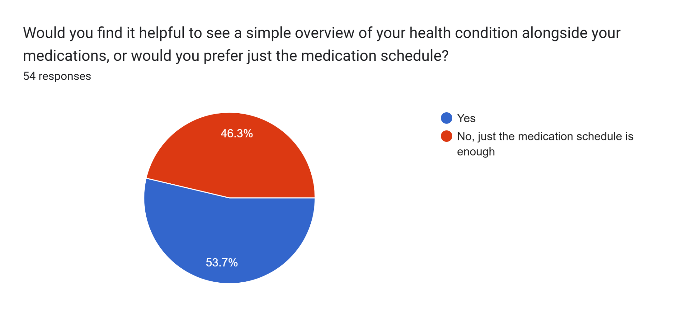
The above data proves that users would like to have a dashboard in a medication reminder app where they can view certain information up front such as the medication required for the day, overall health summary, remaining medication in supply and quick access to medical documents that have been uploaded.

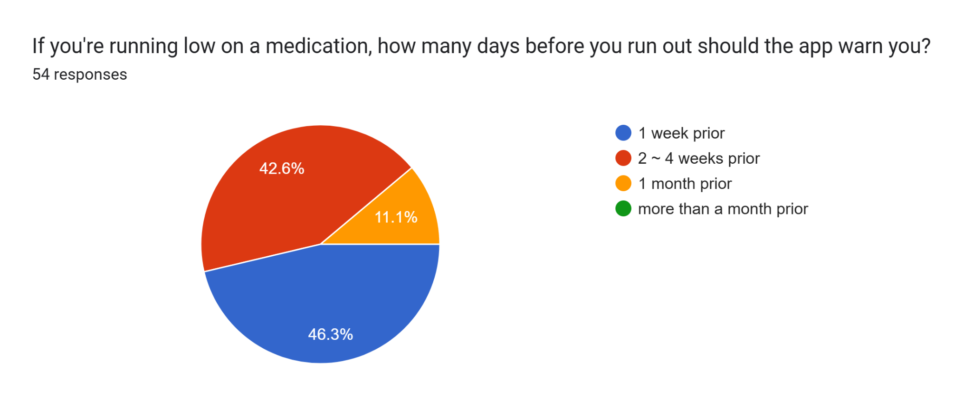When asked when they would like the app to warn them of low medication supply, the responses varied. This indicates that users need to be able to set custom reminders for low supply alerts as they may vary depending on medication. Since the app can’t detect the physical stock of medication that the user has, it relies on the user to input the stock available manually which is an unavoidable constraint with the app.

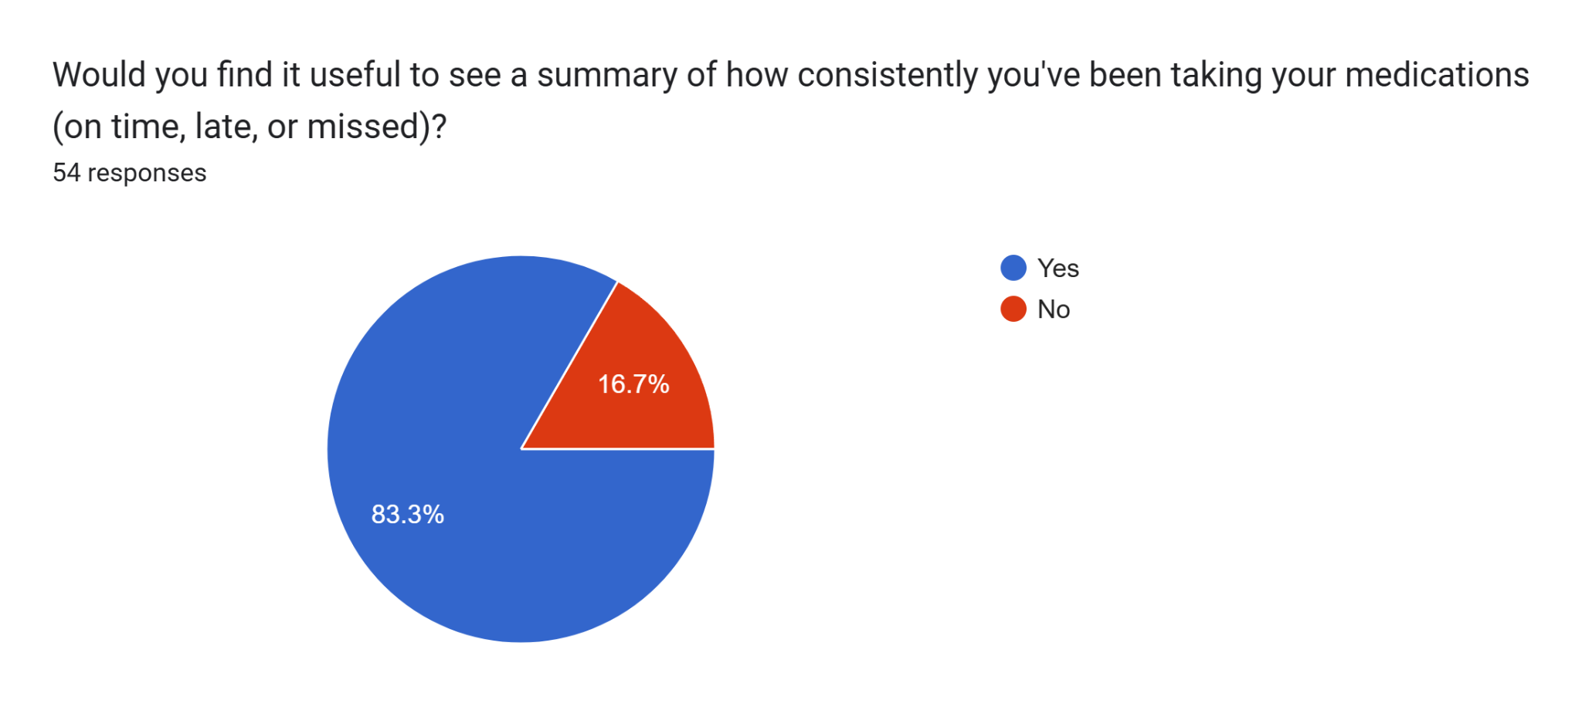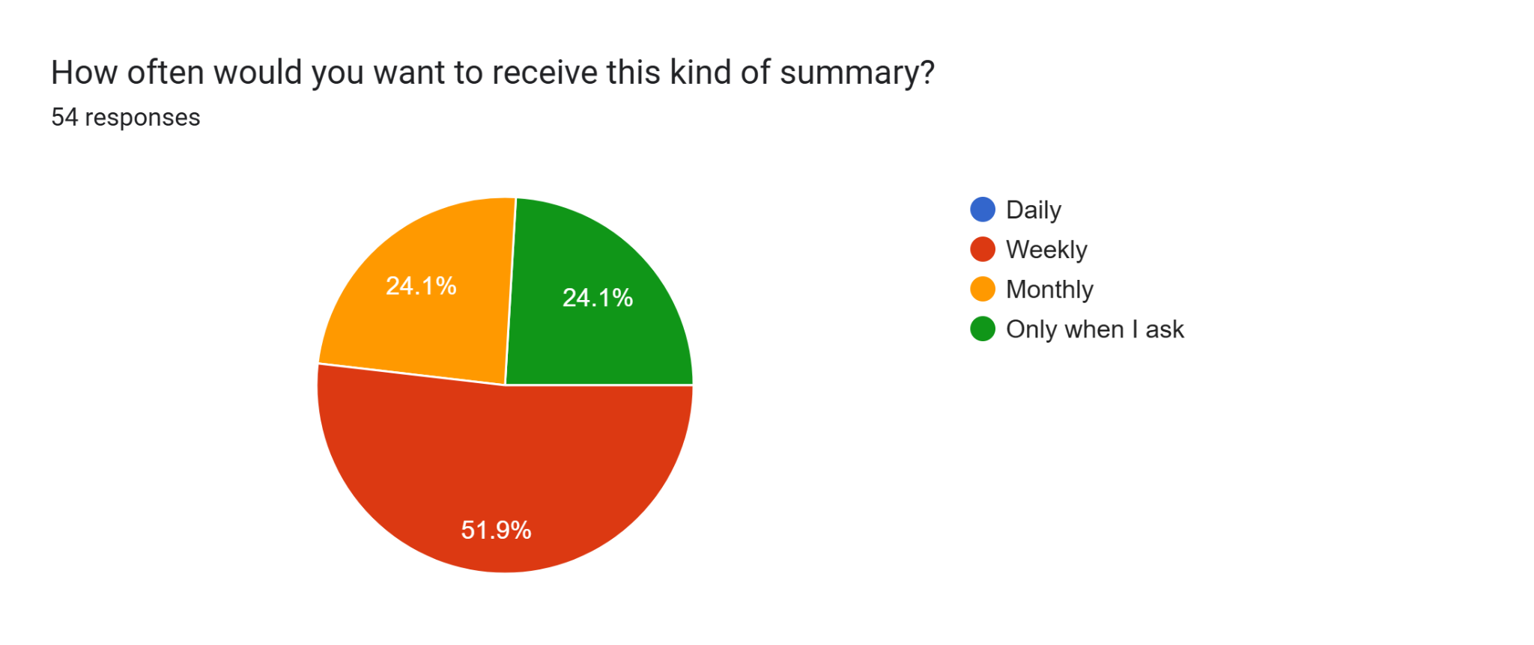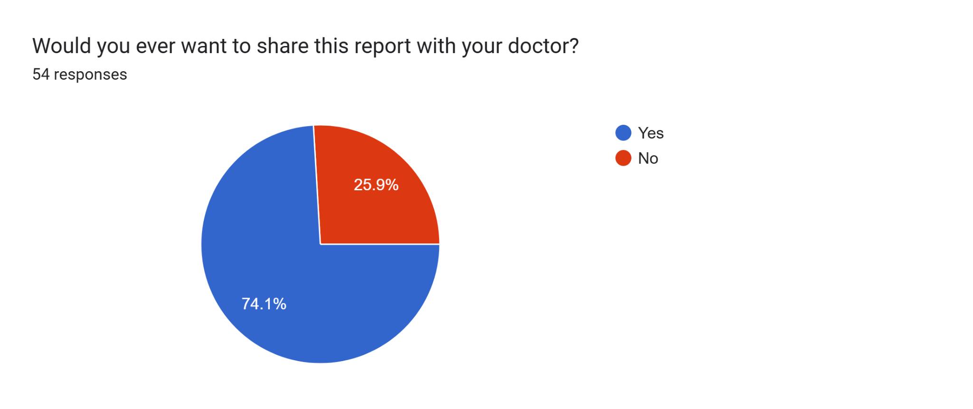
According to the above data, most users would like to have the option to generate reports of their medication history from the app. It would be best to have a feature where they are able to generate a report, which shows medication taken on time, late or missed, whenever they want to. Most respondents confirm that this would be beneficial when sharing their medical history with their doctor and track their own medication adherence.
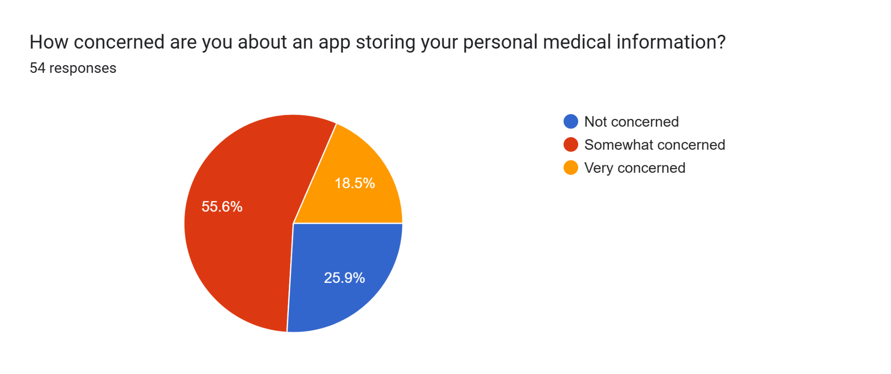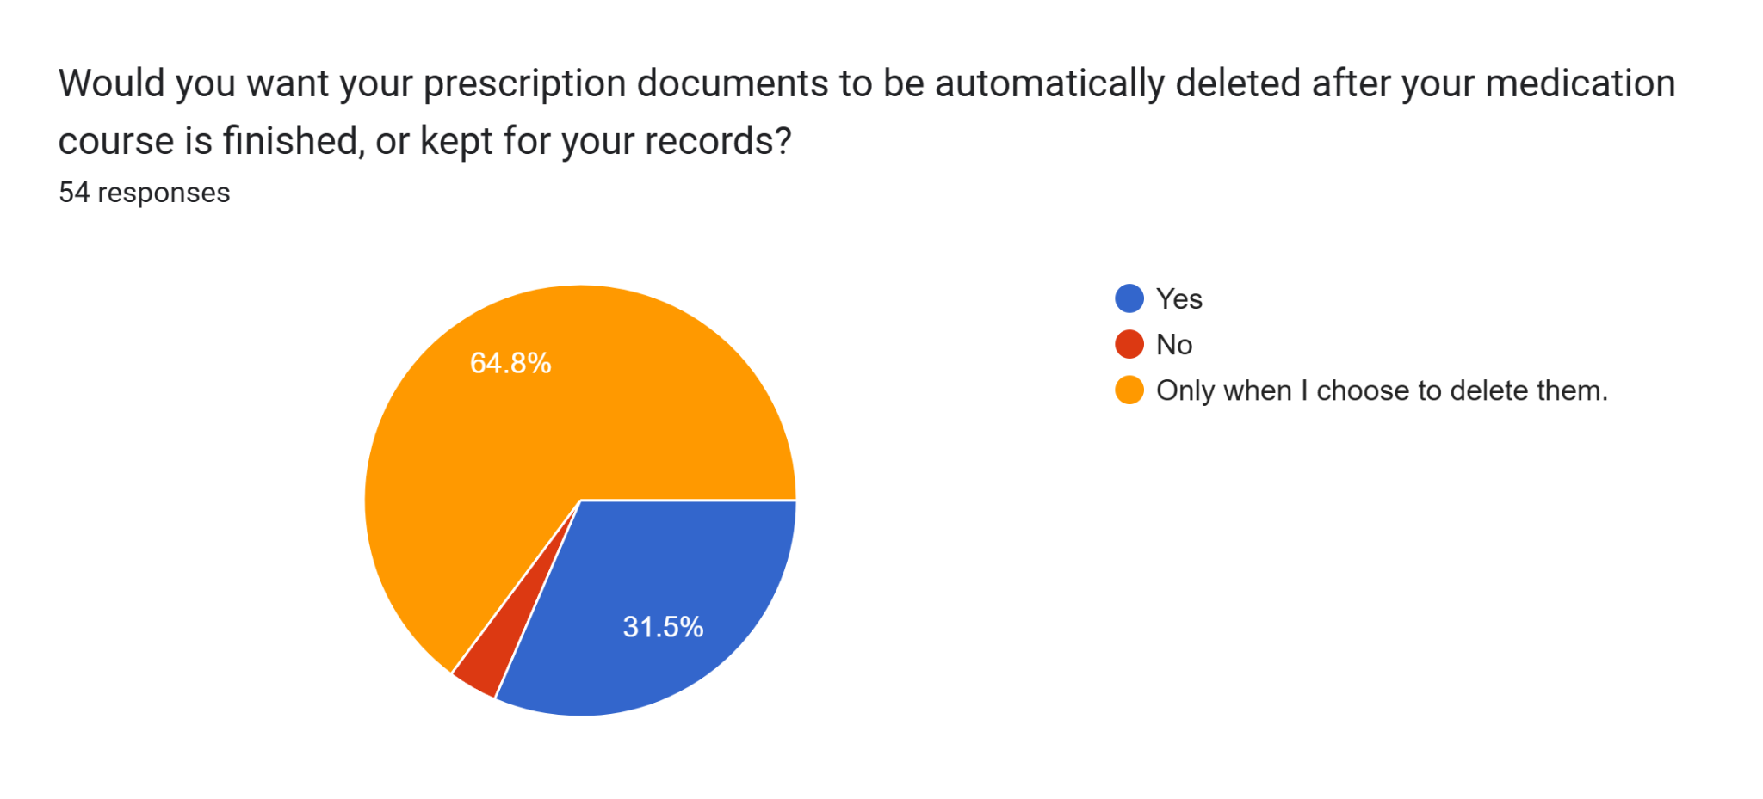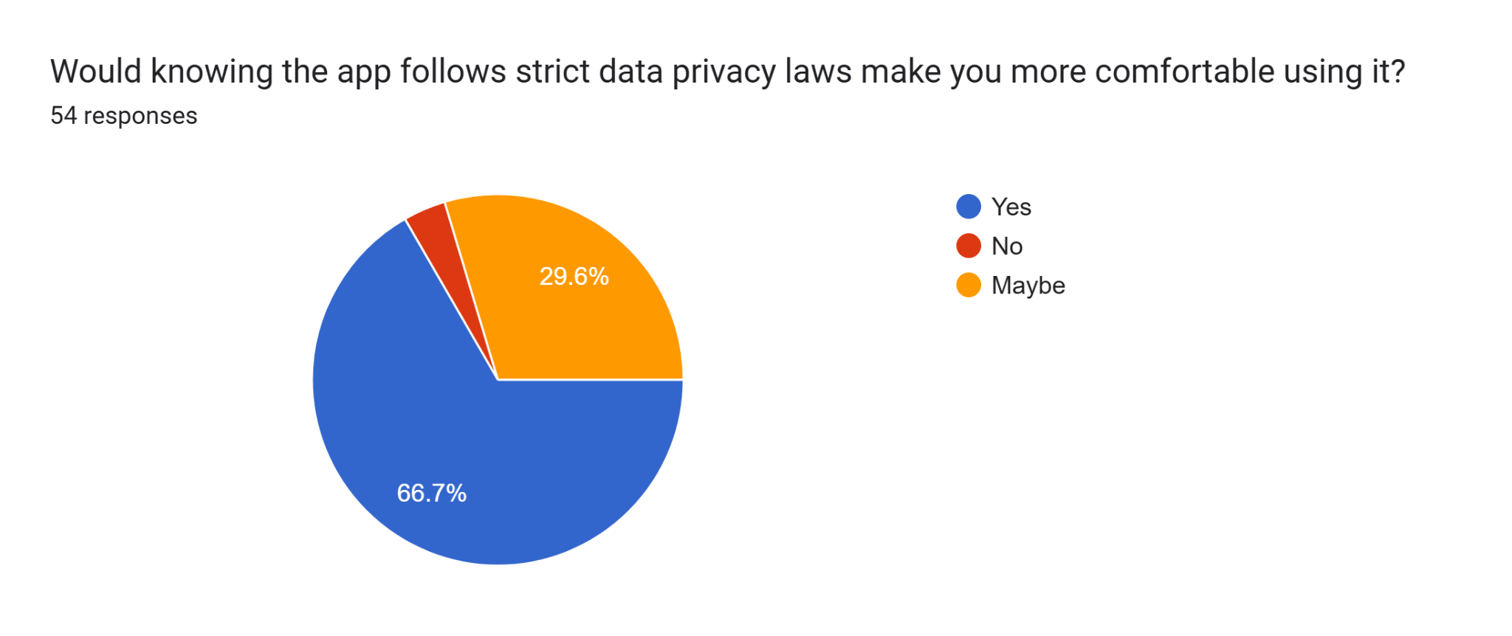The above data shows that most respondents are somewhat hesitant to store their medical information in a medication reminder app, but are open to the idea as long as strict data protection measures are set in place. This leads us to believe that users should be able to control how their data is used, able to delete if they choose to and the app should adhere to the medical data privacy laws of the country the user resides in.
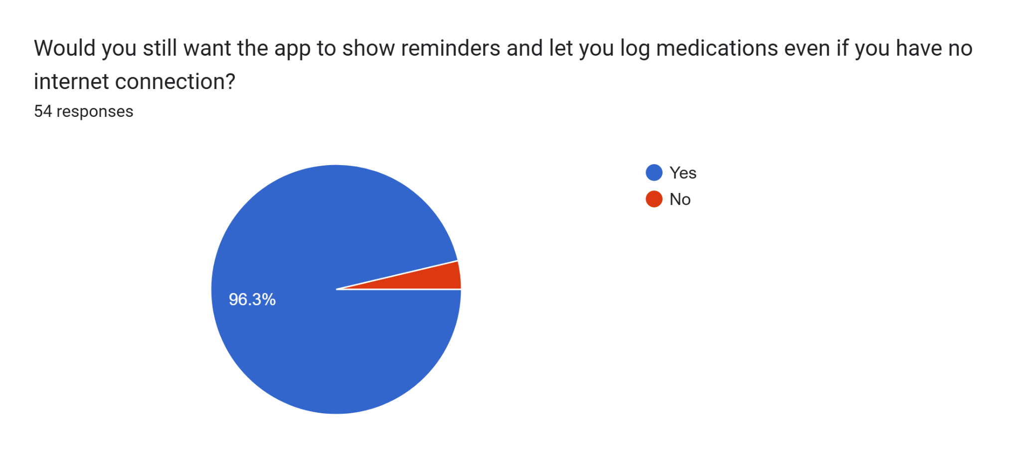
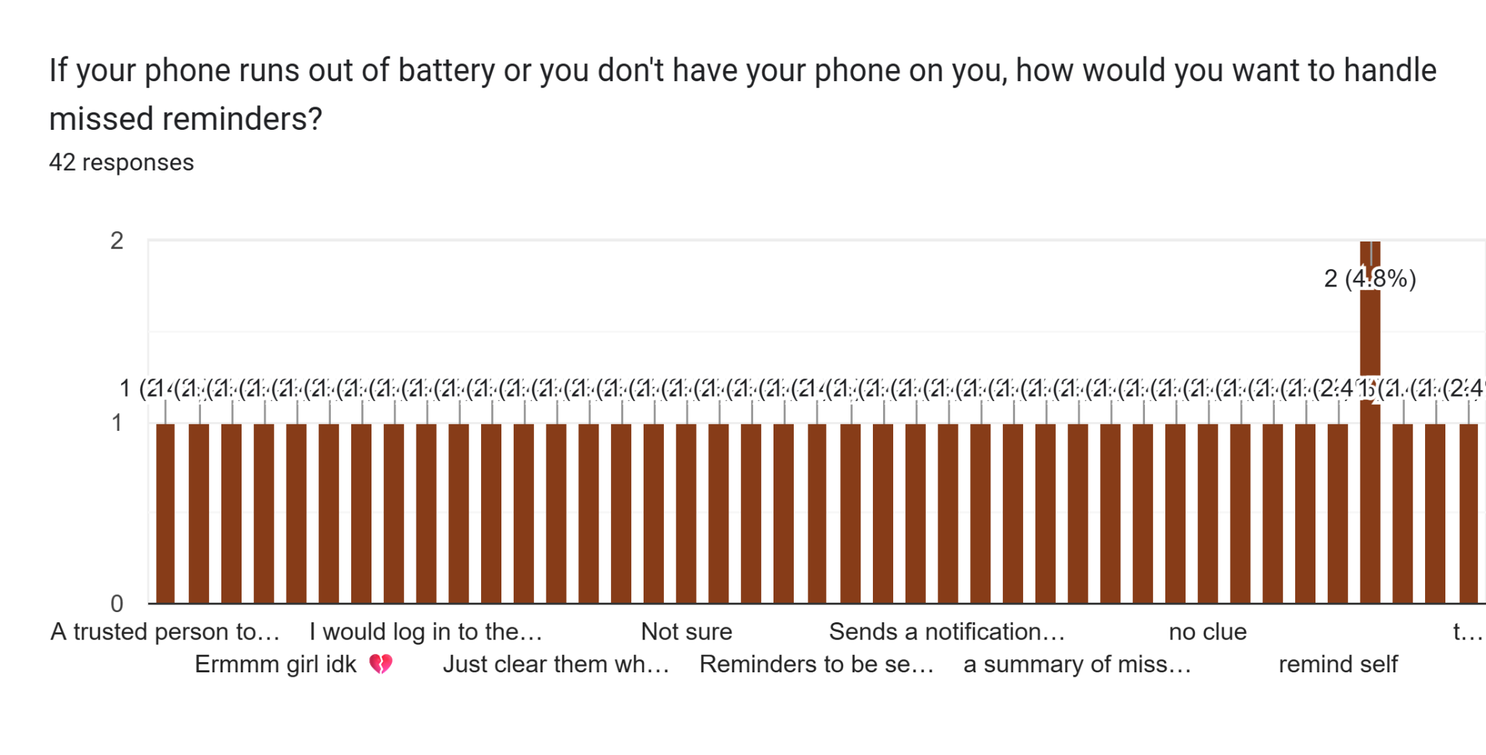
The above data proves that there is a need for the medication reminder app to be able to function offline, which means app data is stored in the device as well as in the cloud. In the event where the user is unable to access the app, depending on the medication priority, the emergency contact may be alerted. This aligns with observations made in previous graphs where emergency contact alert customizability and the option to set priorities for medication were noted as features that users may need.

We also included some open ended questions where we had the respondents give suggestions and feedback. Here are some notable ones we received.
Q. What's the one thing that would make you trust and regularly use a medication reminder app?
- Security & reliability
- Privacy & data safety
- User friendly/ Good UI
- App data syncs through all logged in devices

Q. What would make you stop using it or uninstall it?
- Data breach/leak
- Advertisements
- Too buggy
- Difficult in-app navigation/non intuitive UI

Q. Is there anything else you'd like the app to do that hasn't been mentioned?
- Able to toggle sound effects / customizability
- Overview of medication details (Generic name, common effects, side effects)
- Able to record specifics of medication such as dosage strength
- Able to share medication history with caregivers/trusted person

Analysis of features in existing apps
We analysed the features of two popular medication reminder apps (MyTherapy and Medisafe) and identified core features that are essential to these types of apps.

- Medication Logging
- Automated Reminders
- Medication history maintenance
- Report Generation
- Patient dashboard

MyTherapy specifically, goes one step further and allows you to document blood pressure, weight–so on and so forth. It also allows you to set up reminders to get refills of medication you’re running low on. However, it does not have the option to share medication history with a caregiver/trusted person, which medisafe does quite well.

There were also quite a few negative user reviews for both the apps. Here are some complaints users had:

- Subscription instead of one-time payment
- Too many features creating in-app clutter
- Too many advertisements
- Unable to fix medication logging mistakes due to app restrictions
- Difficult/ not user-friendly UI
- Limited customizability

From this and the survey data we analysed previously, we identified user needs and expectations, project objectives, scope, stakeholders and user groups for the project.

Final Analysis - Requirements

System Scope
In scope:
- User account registration and management
- Medication logging and reminder management
- Prescription scanning and automatic reminder setup
- Patient dashboard with daily overview
- Medication supply tracking and low supply alerts
- Emergency contact alert system
- Medication history recording and report generation

Out of Scope:
- Medical diagnosis or advice of any kind
- Prescribing or recommending medications
- Replacing licensed healthcare providers
- Validating authenticity of prescriptions
- Automatic medication ordering or restocking

User Requirements
Patient:
- Able to register and log in securely so that the patient’s medical information is private and accessible only to them.
- Able to manually add medications and details including dosage, frequency and timing so that all medication can be tracked efficiently.
- Able to upload a photo or digital copy of prescriptions so that reminders can be set up automatically.
- Able to review and confirm prescription information prior to saving to confirm information accuracy.
- Able to review automated reminders for each medication at the set times so that dosage times are not missed.
- Able to log when medicine was taken so that the intake history can be accurately recorded.
- Able to set up an emergency contact so that a trusted party/person can be alerted if a critical medicine is not taken on time.
- Able to view a dashboard showing all daily medications, health conditions, and course progress so that a clear overview of the user’s health is easily seen at a glance.
- Able to track the remaining supply of medication so that the medication can be restocked without any issues.
- Able to receive a low supply alert for medication so that there is time to restock within a reasonable timeframe.
- Able to view full medication history so that it can be referred to at any given time.
- Able to generate medication reports for a selected timeframe/time period so that it can be shared with doctors or caregivers easily.
- Able to share medication reports with doctors or caregivers so that they can monitor the user’s health status.
- Able to manage and delete prescription data at any time so that the user has full control over.

Caregiver/Emergency contact:
- Able to monitor a loved one’s medication intake in order to ensure the medication is being taken correctly.
- Able to receive shared reports from the patient in order to stay informed on their health condition.
- Able to be set as an emergency contact in order to be alerted if a critical medication is missed.

Functional Requirements
User Account Management

- The system shall allow new users to register an account with personal details including name, age, and health conditions.
- The system shall allow registered users to log in securely using their credentials.
- The system shall allow users to update their personal profile at any time.
- The system shall allow users to set up a designated emergency contact with name and contact details.
- The system shall allow users to update or remove their emergency contact at any time.
- The system shall allow users to link their account to a caregiver/trusted person for report sharing
- The system shall allow users to revoke caregiver/trusted person access at any time.

Medication Management

- The system shall allow users to manually add medications including name, dosage, frequency, timing, and associated health condition.
- The system shall allow users to edit or delete existing medication entries.
- The system shall allow users to log when they have taken a medication.
- The system shall record a timestamp for every medication intake logged by the use.
- The system shall mark a medication as missed if it is not logged within the time frame defined by the patient.
- The system shall maintain a complete history of all medication intake logs over time.

Prescription Scanner

- The system shall allow users to upload a photo of a physical prescription via camera capture or gallery upload.
- The system shall allow users to upload a digital prescription in PDF, JPG, or PNG format.
- The system shall automatically extract medication name, dosage, frequency, and timing from the uploaded prescription.
- The system shall display the extracted information for the user to review before saving.
- The system shall allow users to manually edit any extracted information before confirming.
- The system shall only create medication entries and activate reminders after the user explicitly confirms the extracted information.
- The system shall notify the user if a prescription image is unclear or unreadable and prompt them to re-upload.

Reminders & Notifications

- The system shall send automated notifications reminding patients to take their medication at the scheduled time.
- The system shall send individual reminders for each medication based on its specific schedule.
- The system shall allow users to configure reminder settings including frequency, sound, vibration, and snooze options.
- The system shall send a follow-up reminder if the patient does not log the medication within the defined time frame after the first reminder.
- The system shall alert the designated emergency contact if the patient fails to log a critical medication within the defined time window.
- The system shall send a low supply alert when the patient's medication stock falls below the user-defined threshold.
- The system shall allow users to enable or disable low supply reminders per individual medication.
- The system shall allow users to set the low supply threshold in terms of remaining doses or number of days.

Dashboard

- The system shall display a dashboard showing all medications the patient needs to take for the current day.
- The system shall display the patient's logged health conditions on the dashboard.
- The system shall display the remaining doses and course end date for short-term medications on the dashboard.
- The system shall display a low supply indicator on the dashboard for medications running low.
- The system shall update the dashboard in real time as the patient logs medication intake.

Supply Management

- The system shall allow users to manually log the quantity of each medication they have in stock.
- The system shall automatically decrease the logged supply count each time the patient logs a dose as taken.
- The system shall display the current remaining supply for each medication.
- The system shall trigger a low supply alert when the remaining supply falls below the user-defined threshold.

Tracking & Report Generation

- The system shall track and display the patient's full medication intake history.
- The system shall calculate and display the patient's medication adherence rate over a selected time period.
- The system shall allow users to generate reports for daily, weekly, monthly, or yearly time periods.
- The system shall display medications taken on time, taken late, and missed within generated reports.

Non-Functional Requirements

Performance

- The dashboard shall load within 2 seconds upon app launch.
- Push notifications shall be delivered within 30 seconds of the scheduled reminder time.
- The prescription scanner shall return extracted results within 15 seconds of a successful upload.
- Report generation shall complete within 1 minute for records spanning up to 12 months.

Security & Privacy

- The system shall require authentication before granting access to any patient data.
- The system shall comply with the medical data privacy laws and regulations of the patient's country of residence.
- Patients shall be able to view, manage, and permanently delete their personal and prescription data at any time.

Reliability

- The reminder system shall maintain 99% uptime to ensure no reminders are missed.
- The system shall recover from an unexpected crash without loss of any logged medication data.
- Emergency contact alerts shall achieve a delivery success rate of at least 99%.
- The app shall allow users to view their dashboard and medication history in offline mode.
- The app shall automatically sync all offline changes to the server when internet connectivity is restored.

Usability

- The app shall be usable by users with no prior technical experience.
- The app shall support adjustable text sizes to accommodate elderly users.
- The prescription scanner confirmation screen shall clearly highlight all extracted fields for easy review and editing.

Compatibility

- The app shall be compatible with iOS and Android devices.
- The app shall function correctly on both smartphones and tablets.

References
Medisafe. (2026, January 21). Digital Health • Platform • Adherence • Persistence • Solutions | Medisafe. https://www.medisafe.com/

Medication Reminder and Pill Tracker App 💊⏰📲– MyTherapy. (n.d.). https://www.mytherapyapp.com/

